## **4.5 Proposed Real World Water Treatment Design**

4.5.1 Log Inactivation Credit Discussion

Caf = 0.11 mg/Litre

Our designed Volume for the CFSTR V = 570L

Our designed flow rate q = 50 litres/min

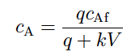

The the entire temperature range is 15, 20, 25, 30 and 35℃.

For 15 degrees, Ca = 0.189 mol/litre and Cd = 0.011 mol/litre

For 20 degrees, Ca = 0.189 mol/litre and Cd = 0.011 mol/litre

For 25 degrees, Ca = 0.189 mol/litre and Cd = 0.011 mol/litre

For 30 degrees, Ca = 0.189 mol/litre and Cd = 0.011 mol/litre

For 35 degrees, Ca = 0.189 mol/litre and Cd = 0.011 mol/litre

Ozone decay rate constants Calculation:

Pathogen inactivation rate constants:

Log inaction values for viruses and Giardia inactivation rate constants (using the CFSTR model outputs)

A table & calculation to show CFSTR Operation Speciﬁcs meet the constraints and speciﬁcation of the design brief.

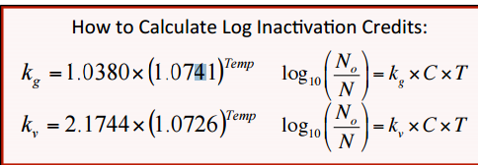

|  |  |  |  |  |
| --- | --- | --- | --- | --- |
| Temperature (C) | Volume (L) | Inlet Flow Rate (L/min) | Operation Time (hours) | Residence Time (min) |
| 15 | 300 | 25 | 3.8 | 12 |
| 20 | 250 | 25 | 3.8 | 10 |
| 25 | 250 | 25 | 3.8 | 10 |
| 30 | 250 | 25 | 3.8 | 10 |
| 35 | 250 | 25 | 3.8 | 10 |

|  |  |  |  |  |
| --- | --- | --- | --- | --- |
| k rate constant | Virus Credit | Giardia Credit | CA (mol/liter) | Cd (mol/liter) |
| 0.022359586 | 6.475198976 | 3.156566127 | 0.087 | 0.023 |
| 0.036481431 | 7.118924894 | 3.494707277 | 0.081 | 0.029 |
| 0.049510513 | 9.225824924 | 4.560749529 | 0.074 | 0.036 |
| 0.06301338 | 12.01275586 | 5.980097759 | 0.067 | 0.043 |
| 0.099021026 | 13.96869729 | 7.002549037 | 0.055 | 0.055 |

All Virus Credit and Giardia Credit meet the requirement, Operation Time are less than 4 hours and Residence Time are more than 10 minutes. So, our design meets all the requirements.